
MRCA FOUNDATION
SCHOLARSHIP APPLICATION


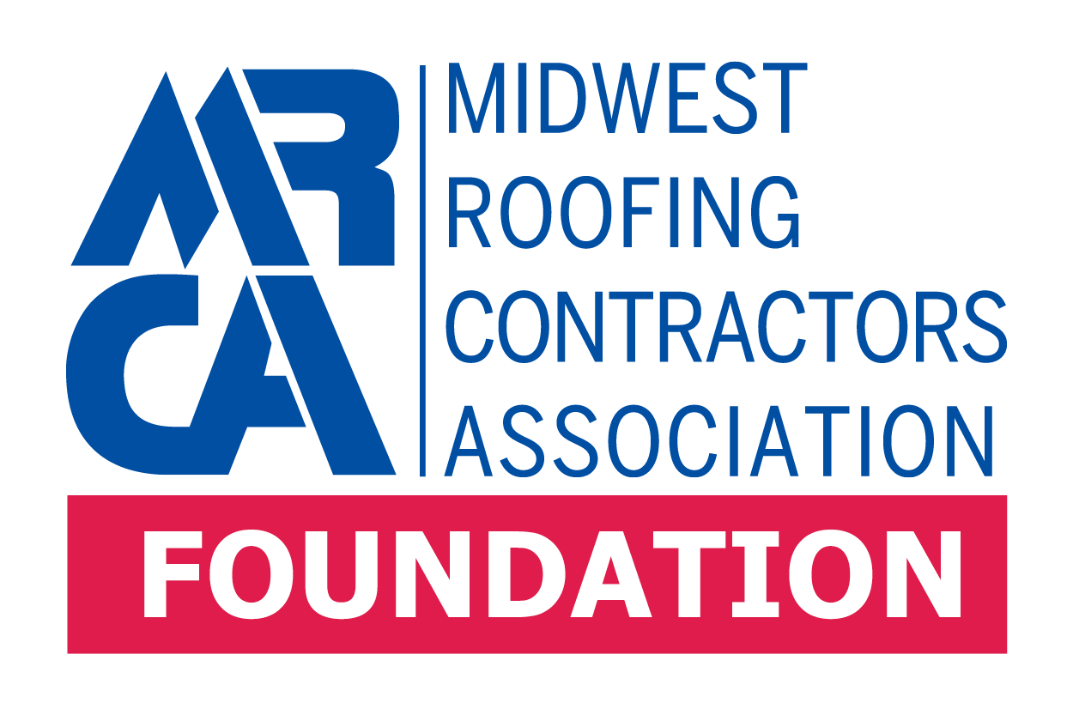
2026-2027 ACADEMIC YEAR
APPLICATION PACKET

Online application available at www.mrca.org
YOU CAN ALSO APPLY ONLINE AT MRCA.ORG UNDER THE FOUNDATION TAB

Foundation Scholarship Application

Name of Applicant:
(please print or type)

The MRCA Foundation is a non-profit organization established by the Midwest Roofing Contractors Association (MRCA). One purpose of the Foundation is to provide financial assistance to MRCA member company employees and their families pursuing higher education at an accredited university or trade school.

ELIGIBILITY
Candidates must be an undergraduate or graduate student enrolled in a trade school, college, or university, or a high school senior provisionally accepted at an educational institution and expressing intent to pursue a degree or certified trade program with at least a 3.0 GPA or B Average Equivalent.

APPLICATION REQUIREMENTS

Candidates must submit the following to be considered for a scholarship award:
- A fully-completed application
- Proof of being associated with an active MRCA member company
- A written statement from the educational institution where the trade-related, undergraduate or graduate work will be undertaken, indicating provisional acceptance of the student at the institution
- Official transcripts from current high school or educational institution showing at least a 3.0 GPA
- Two letters of recommendation, submitted by persons at least 18 years of age who are not related to the candidate. Only one letter of recommendation may come from a Director of the MRCA Board, however, none may come from a Director of the MRCA Foundation Board
- A typed essay of no more than one page, explaining why the applicant is interested in pursuing a degree in their field of study and any steps that have been taken to pursue this goal including relevant honors, activities, or employment. If it is determined that AI was used to create your essay, you will be automatically disqualified.

SCHOLARSHIP AWARDS
The number and dollar amount of scholarships awarded by the MRCA Foundation will be determined by the MRCA Foundation Board of Directors.

SELECTION
Scholarship recipients will be selected on the basis of academic performance, employment experience, financial need, letters of recommendation, and a demonstrated desire to pursue higher education. All applicants will be notified in writing by the MRCA Staff, and the award will be mailed to the specified school.

DEADLINE
Entries, including all required information, must be electronically submitted or postmarked no later than May 1, 2026 to be considered for the 2026-2027 academic year. Applications and supporting documentation shall be mailed to: MRCA Foundation, Attn: Emily Mandich, 7250 Poe Ave., Suite 410 Dayton, Ohio 45414 or emailed to emandich@mrca.org. Website to apply online is mrca.org and the scholarship application can be found under the Foundation tab.

APPLICANT: Please complete all sections of this application:
(Please type or print clearly)

- PERSONAL
A. Name:
First Middle Last

B. Home Address:
Street City State Zip Code

Home Telephone: _______________ Cell Phone: ____________________ Email: ___________________________

- MRCA Member Company, City, State: ___________________________________________________________
Relationship to employee at member-company (circle one and provide name):
Mother Father Aunt Uncle Grandparent Other (provide details)
_________________________________________________________________________________________
D. Name and address of the educational institution you are currently attending or from which your
provisional acceptance has been made:

Name of School Student ID # (if available)

Street City State Zip Code

E. Indicate the highest education level you have completed at time of application:

High School Senior Freshman Sophomore Junior Senior Graduate School

F. What is your grade point average (GPA) at the time of application? (3, 4, 5, or 6 point scale – circle one)

G. In what program do you expect to get your degree?

List any extracurricular activities in which you have participated in high school and college:

(1) Student activities

(2) Community activities

(3) Athletics

(4) Other

II. FINANCIAL INFORMATION
- Total household annual income (including parents or spouse):
0K-50K _____ 50K-125K _____ 125K- More _____
B. Number of siblings living at home:
C. Including yourself, how many members of your immediate family will be enrolled in college during the
upcoming school year?
D. Estimate of college expenses:
- Tuition: $ per year
- Books: $ per year
- Room and Board $ per year
- Other (please specify) $ per year
TOTAL $ per year

E. What percent of your college education and living expenses do you expect scholarships and grants to provide?
___________%

F. Please list the amount of scholarships from other organizations (excluding any grants) that you have been
awarded that will fund your educational expenses?

III. ADDITIONAL INFORMATION – please list any additional information that you would like for the Foundation Board to be aware of:

IV. Have you previously been awarded a scholarship from the MRCA Foundation? Yes No (circle one)

If yes, what year(s) were you awarded?

I agree that this application and all attachments may be used by the Board of Directors of the MRCA Foundation or any representatives designated by the Board of Directors, for the purpose of evaluating and selecting recipients of scholarship awards. I represent that all information submitted in conjunction with this application is true and correct to the best of my knowledge. I understand that false information is cause for disqualification.

Signature of Applicant Date

